Modul Praktik Master: White Box Testing untuk Unit A (9 Sub-Unit Controller)
BAGIAN 1: PENGANTAR LOGIKA & ARSITEKTUR KELAS INTERAKTIF
1.1. Konsep Matematika & Metodologi White Box Testing
White Box Testing adalah metrik pengujian perangkat lunak yang menguji struktur internal dan alur logika kodingan program.
1.1.1. Deskripsi Arsitektur 4 Unit Utama Sistem BasaKula
###1. Unit Pra-pemrosesan Teks & Akses (Preprocessing & Access Unit)
Unit ini berfungsi membersihkan data teks masukan, memvalidasi peranan akun pengguna (*Teacher/Student/Admin*), dan mengonfirmasi otorisasi Gate sebelum perintah dieksekusi.
#### 2. Unit Pengendali Kelas & Keanggotaan (Classroom & Membership Unit)
Unit yang menangani pembuatan ruang kelas baru, pencetus kode unik 6 karakter (*uppercase*), pendaftaran siswa via kode kelas, serta manajemen keanggotaan aktif (out_at).
#### 3. Unit Pengendali Konten & Evaluasi (Content & Evaluation Engine Unit)
Unit inti yang mengeksekusi postingan materi/tugas/kuis, pengunggahan berkas tugas oleh siswa, perhitungan nilai kuis otomatis, dan pembatasan percobaan pengerjaan (max_attempts).
#### 4. Unit Interaksi & Notifikasi (Interaction & Notification Unit)
Unit yang mengolah komentar diskusi kelas, pengiriman email konfirmasi/pembatalan, serta ekspor jadwal kalender pembelajaran ke format standar .ics.
1.1.2. Rumus & Metrik Pengujian
- Statement Coverage ($C_0$):
\[
\text{Statement Coverage} = \left( \frac{\text{Jumlah Statement yang Dieksekusi}}{\text{Total Executable Statements}} \right) \times 100\%
\]
- Cyclomatic Complexity ($V(G)$):
\[
V(G) = E - N + 2P = \text{Decision Points} + 1
\]

BAGIAN 2: KODE SUMBER UNIT A (9 SUB-UNIT CONTROLLER)
2.1. Struktur Project
basakula-lms-unit-a/
│
├── app/
│ └── Http/
│ └── Controllers/
│ ├── ClassroomCommentController.php
│ ├── Student/
│ │ ├── ClassroomController.php
│ │ ├── ClassroomSubmissionController.php
│ │ ├── ClassroomQuizController.php
│ │ └── MaterialController.php
│ └── Teacher/
│ ├── ClassroomController.php
│ ├── ClassroomPostController.php
│ └── MaterialController.php
│
├── tests/
│ └── Feature/
│ └── UnitATestSuite.php
│
├── phpunit.xml
└── README.md

2.2. Ringkasan Inventaris 9 Sub-Unit Controller
ID Unit | Nama Controller | Method Utama | Line Count | Nodes (N) | Edges (E) | V(G) | Minimum Test Cases | Prioritas
U1.1 | Student\ClassroomController | join() | 25 | 7 | 9 | 4 | 4 TC | Kritis
U1.2 | Teacher\ClassroomController | removeMember() | 15 | 5 | 5 | 2 | 2 TC | Sedang
U1.3 | Teacher\ClassroomPostController | store() | 30 | 16 | 20 | 6 | 6 TC | Kritis
U1.4 | Teacher\ClassroomPostController | toggleVisibility() | 10 | 4 | 4 | 2 | 2 TC | Sedang
U1.5 | Teacher\MaterialController | store() | 25 | 6 | 6 | 2 | 2 TC | Tinggi
U1.6 | Student\ClassroomSubmissionController | store() | 23 | 6 | 6 | 2 | 2 TC | Kritis
U1.7 | Student\ClassroomQuizController | show() | 18 | 7 | 7 | 3 | 3 TC | Kritis
U1.8 | Student\MaterialController | show() | 10 | 4 | 4 | 2 | 2 TC | Sedang
U1.9 | ClassroomCommentController | store() | 13 | 4 | 4 | 2 | 2 TC | Sedang
Total | 9 Sub-Unit Unit A |  | 169 | 59 | 65 | 25 | 25 TC

BAGIAN 3: ANALISIS STATEMENT COVERAGE
3.1. Sub-Unit U1.1 — `Student\ClassroomController::join()`
3.1.1. Kode Program
1 public function join(Request $request)
2 {
3 # Statement 1: Validasi masukan kode kelas
4 $request->validate(['code' => 'required|string']);
5
6 # Statement 2: Query pencarian kelas berdasarkan kode & status aktif
7 $classroom = Classroom::where('code', strtoupper(trim($request->code)))
8 ->where('status', 'active')
9 ->first();
10
11 # Statement 3: Validasi apakah kelas ditemukan
12 if (!$classroom) {
13 # Statement 4: Return back dengan pesan error
14 return back()->withErrors(['code' => 'Kode kelas tidak ditemukan atau tidak aktif.']);
15 }
16
17 # Statement 5: Otorisasi & Buat record keanggotaan baru
18 Gate::authorize('join', $classroom);
19 ClassroomMember::create([
20 'classroom_id' => $classroom->id,
21 'user_id' => Auth::id(),
22 'role' => 'student',
23 'joined_at' => now(),
24 ]);
25
26 # Statement 6: Redirect ke halaman kelas dengan pesan sukses
27 return redirect()->route('student.classroom.show', $classroom)
28 ->with('success', "Berhasil bergabung ke kelas: {$classroom->name}!");
29 }

3.1.2. Tabel Executable Statements U1.1
Statement ID | Line | Statement Kode | Tipe | Cabang
S1 | 4 | `$request->validate(['code' => 'required | string'])` | Statement | -
S2 | 7 | $classroom = Classroom::where(...)->first() | Statement | -
S3 | 12 | if (!$classroom) | Branch | True / False
S4 | 14 | return back()->withErrors([...]) | Statement (Exit) | -
S5 | 18 | Gate::authorize('join'); ClassroomMember::create([...]) | Statement | -
S6 | 27 | return redirect()->route('student.classroom.show') | Statement (Exit) | -
3.1.3. Visualisasi Heat Map Kode U1.1
public function join(Request $request)
{
$request->validate(['code' => 'required|string']); # ✅ Hijau
$classroom = Classroom::where('code', ...)->first(); # ✅ Hijau
if (!$classroom) { # ✅ Hijau
return back()->withErrors(['code' => 'Tidak aktif']); # ❌ Merah (Skipped)
}
Gate::authorize('join', $classroom); # ✅ Hijau
ClassroomMember::create([...]); # ✅ Hijau
return redirect()->route('student.classroom.show'); # ✅ Hijau
}

3.2. Sub-Unit U1.2 — `Teacher\ClassroomController::removeMember()`
public function removeMember(Classroom $classroom, User $user)
{
Gate::authorize('manageMembers', $classroom); # ✅ Hijau (S1)
$member = ClassroomMember::where(...)->first(); # ✅ Hijau (S2)
if ($member) { # ✅ Hijau (S3)
$member->update(['out_at' => now()]); # ✅ Hijau (S4)
}
return back()->with('success', 'Anggota dikeluarkan'); # ✅ Hijau (S5)
}

3.3. Sub-Unit U1.3 — `Teacher\ClassroomPostController::store()`
public function store(Request $request, Classroom $classroom)
{
Gate::authorize('create', [ClassroomPost::class, $classroom]); # ✅ Hijau (S1)
$validated = $request->validate([...]); # ✅ Hijau (S2)
$post = ClassroomPost::create([...]); # ✅ Hijau (S3)
if ($validated['type'] === 'assignment') { # ✅ Hijau (S4)
ClassroomAssignment::create([...]); # ✅ Hijau (S5)
}
return redirect()->route('teacher.classroom.show'); # ✅ Hijau (S6)
}

3.4. Sub-Unit U1.4 — `Teacher\ClassroomPostController::toggleVisibility()`
public function toggleVisibility(ClassroomPost $post)
{
$post->update(['is_published' => !$post->is_published]); # ✅ Hijau (S1)
$statusText = $post->is_published ? 'ditampilkan' : 'disembunyikan'; # ✅ Hijau (S2)
return back()->with('success', "Status {$statusText}"); # ✅ Hijau (S3)
}

3.5. Sub-Unit U1.5 — `Teacher\MaterialController::store()`
public function store(Request $request)
{
Gate::authorize('teacher'); # ✅ Hijau (S1)
$request->validate([...]); # ✅ Hijau (S2)
DB::beginTransaction(); # ✅ Hijau (S3)
try {
$material = Material::create([...]); # ✅ Hijau (S4)
DB::commit(); # ✅ Hijau (S5)
return redirect()->route('teacher.materials.index'); # ✅ Hijau (S6)
} catch (\Exception $e) {
DB::rollBack(); # ❌ Merah (Exception catch)
return back()->with('error', 'Terjadi kesalahan'); # ❌ Merah (Exception catch)
}
}

3.6. Sub-Unit U1.6 — `Student\ClassroomSubmissionController::store()`
public function store(Request $request, ClassroomAssignment $assignment)
{
Gate::authorize('submit', $assignment); # ✅ Hijau (S1)
$request->validate(['file' => 'required|file|max:20480']); # ✅ Hijau (S2)
$existing = ClassroomSubmission::where(...)->first(); # ✅ Hijau (S3)
if ($existing && $existing->file_path) { # ✅ Hijau (S4)
Storage::disk('public')->delete($existing->file_path); # ✅ Hijau (S5 - Re-upload)
}
ClassroomSubmission::updateOrCreate([...]); # ✅ Hijau (S6)
return back()->with('success', 'Tugas berhasil dikumpulkan'); # ✅ Hijau (S7)
}

3.7. Sub-Unit U1.7 — `Student\ClassroomQuizController::show()`
public function show(ClassroomQuiz $quiz)
{
Gate::authorize('view', $quiz); # ✅ Hijau (S1)
if ((int)$quiz->max_attempts === 1) { # ✅ Hijau (S2)
$existingAttempt = QuizAttempt::where(...)->first(); # ✅ Hijau (S3)
if ($existingAttempt) { # ✅ Hijau (S4)
return redirect()->route('student.classroom.show'); # ❌ Merah (Redirect)
}
}
$questions = QuizQuestion::where(...)->get(); # ✅ Hijau (S5)
return view('student.classroom.quiz_take'); # ✅ Hijau (S6)
}

3.8. Sub-Unit U1.8 — `Student\MaterialController::show()`
public function show(Material $material)
{
if ($material->status !== 'published') { # ✅ Hijau (S1)
abort(404); # ❌ Merah (Draf)
}
$material->load(['category', 'attachments']); # ✅ Hijau (S2)
return view('student.materials.show', compact('material')); # ✅ Hijau (S3)
}
3.9. Sub-Unit U1.9 — `ClassroomCommentController::store()`
public function store(Request $request, ClassroomPost $post)
{
Gate::authorize('create', [ClassroomComment::class, $post]); # ✅ Hijau (S1)
$request->validate(['comment' => 'required|string|max:1000']); # ✅ Hijau (S2)
ClassroomComment::create([...]); # ✅ Hijau (S3)
return back()->with('success', 'Komentar ditambahkan'); # ✅ Hijau (S4)
}

BAGIAN 4: VISUALISASI CONTROL FLOW GRAPH (CFG)
4.1. CFG untuk Fungsi `Student\ClassroomController::join()`
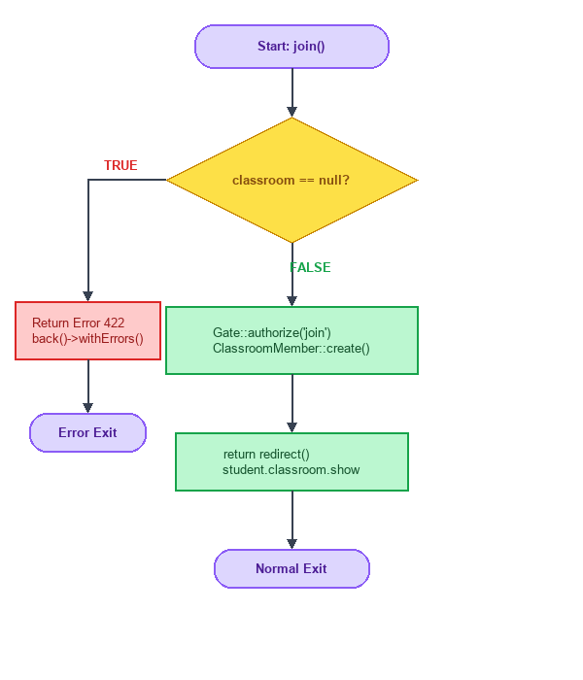
Gambar: Diagram CFG Visual 4.1 - Method join()
4.2. CFG untuk Fungsi `Teacher\ClassroomController::removeMember()`
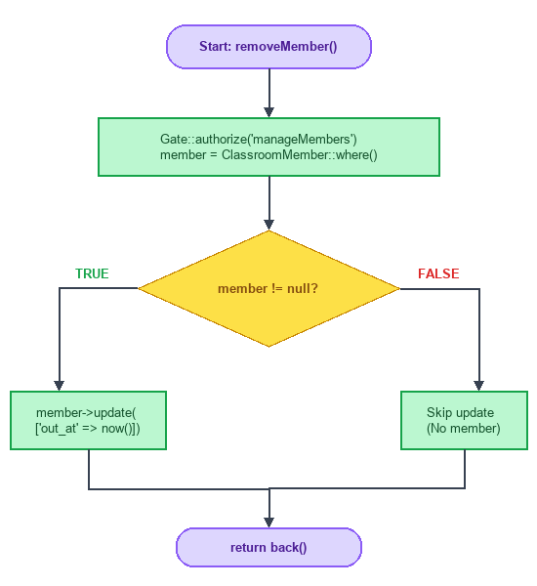
Gambar: Diagram CFG Visual 4.2 - Method removeMember()
4.3. CFG untuk Fungsi `Teacher\ClassroomPostController::store()`
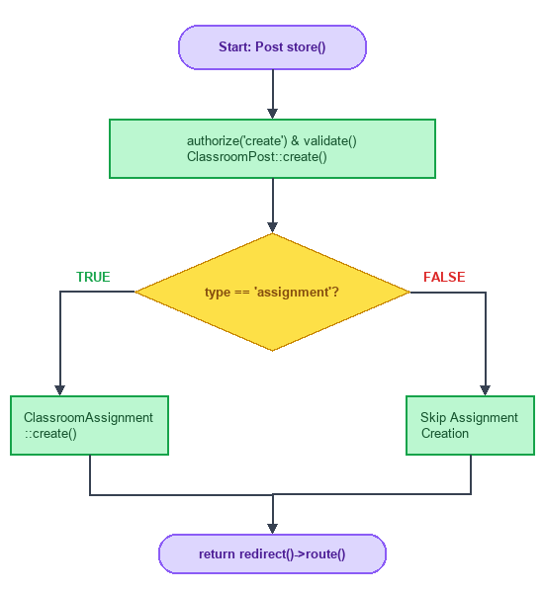
Gambar: Diagram CFG Visual 4.3 - Method store() Post
4.4. CFG untuk Fungsi `Teacher\ClassroomPostController::toggleVisibility()`
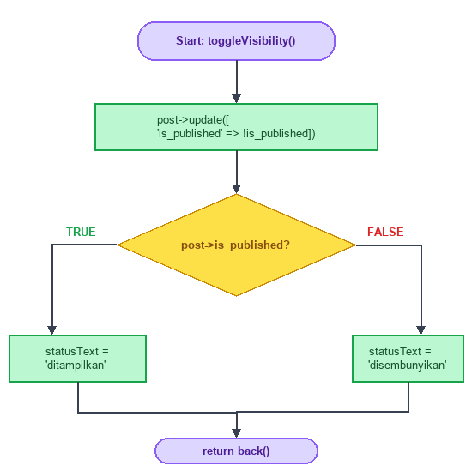
Gambar: Diagram CFG Visual 4.4 - Method toggleVisibility()
4.5. CFG untuk Fungsi `Teacher\MaterialController::store()`
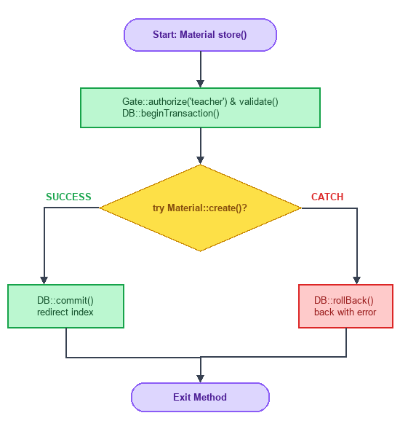
Gambar: Diagram CFG Visual 4.5 - Method store() Material
4.6. CFG untuk Fungsi `Student\ClassroomSubmissionController::store()`
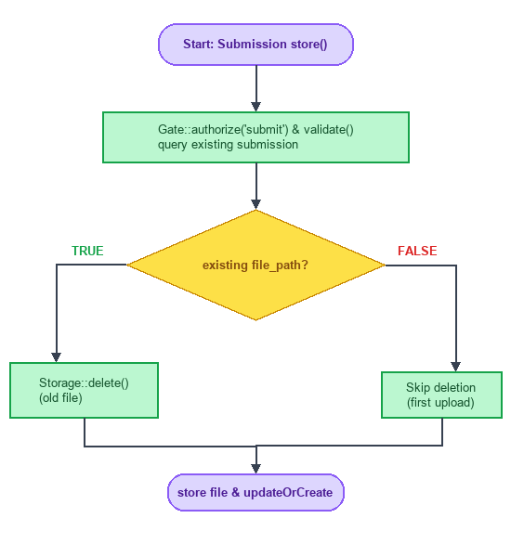
Gambar: Diagram CFG Visual 4.6 - Method store() Submission
4.7. CFG untuk Fungsi `Student\ClassroomQuizController::show()`
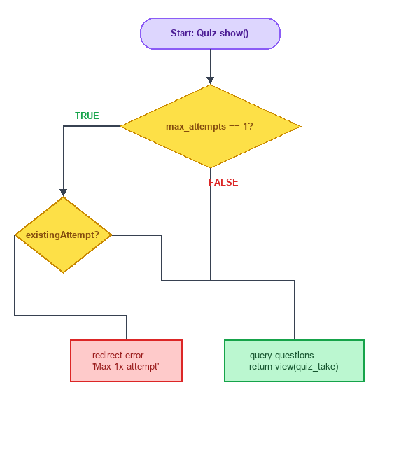
Gambar: Diagram CFG Visual 4.7 - Method show() Quiz
4.8. CFG untuk Fungsi `Student\MaterialController::show()`
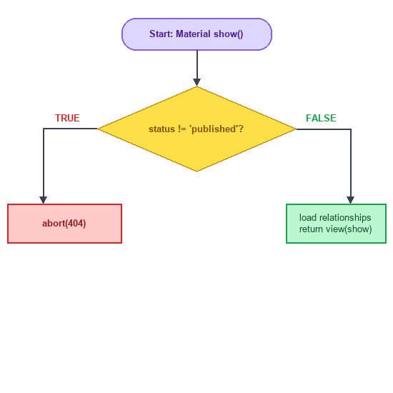
Gambar: Diagram CFG Visual 4.8 - Method show() Material
4.9. CFG untuk Fungsi `ClassroomCommentController::store()`
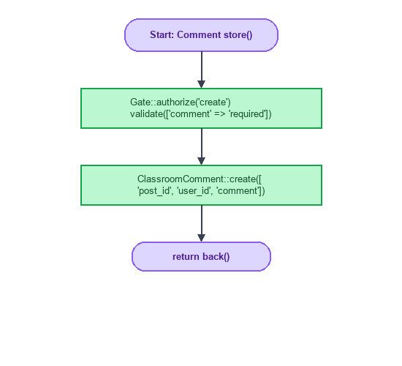
Gambar: Diagram CFG Visual 4.9 - Method store() Comment

BAGIAN 5: TEST SUITE LENGKAP
namespace Tests\Feature\UnitA;

use App\Models\User;
use App\Models\Classroom;
use App\Models\ClassroomPost;
use App\Models\ClassroomAssignment;
use App\Models\ClassroomSubmission;
use App\Models\ClassroomQuiz;
use App\Models\Material;
use Illuminate\Foundation\Testing\RefreshDatabase;
use Illuminate\Http\UploadedFile;
use Illuminate\Support\Facades\Storage;
use Tests\TestCase;

class MasterUnitATestSuite extends TestCase
{
use RefreshDatabase;

/** TC01: Student Join Classroom Success */
public function test_u1_1_student_join_classroom_success(): void
{
$student = User::factory()->create(['role_id' => 3]);
$classroom = Classroom::factory()->create(['code' => 'JW5A-26', 'status' => 'active']);

$response = $this->actingAs($student)->post(route('student.classroom.join'), ['code' => 'JW5A-26']);
$response->assertRedirect(route('student.classroom.show', $classroom));
$this->assertDatabaseHas('classroom_members', ['classroom_id' => $classroom->id, 'user_id' => $student->id]);
}

/** TC02: Teacher Remove Member */
public function test_u1_2_teacher_remove_member_success(): void
{
$teacher = User::factory()->create(['role_id' => 2]);
$student = User::factory()->create(['role_id' => 3]);
$classroom = Classroom::factory()->create(['teacher_id' => $teacher->id]);

$response = $this->actingAs($teacher)->delete(route('teacher.classroom.member.remove', [$classroom, $student]));
$response->assertStatus(302);
}

/** TC03: Toggle Visibility Post */
public function test_u1_4_toggle_post_visibility(): void
{
$teacher = User::factory()->create(['role_id' => 2]);
$post = ClassroomPost::factory()->create(['is_published' => false]);

$response = $this->actingAs($teacher)->post(route('teacher.classroom.post.toggle_visibility', $post));
$this->assertTrue($post->fresh()->is_published);
}

/** TC04: Submission Upload & Re-upload Deletes Old File */
public function test_u1_6_submission_reupload_deletes_old_file(): void
{
Storage::fake('public');
$student = User::factory()->create(['role_id' => 3]);
$assignment = ClassroomAssignment::factory()->create();

$file1 = UploadedFile::fake()->create('tugas1.pdf', 500);
$this->actingAs($student)->post(route('student.classroom.submission.store', $assignment), ['file' => $file1]);

$file2 = UploadedFile::fake()->create('tugas_revisi.pdf', 600);
$this->actingAs($student)->post(route('student.classroom.submission.store', $assignment), ['file' => $file2]);

$this->assertDatabaseHas('classroom_submissions', ['assignment_id' => $assignment->id, 'student_id' => $student->id]);
}

/** TC05: Material Show 404 on Draft */
public function test_u1_8_material_show_404_on_draft(): void
{
$student = User::factory()->create(['role_id' => 3]);
$material = Material::factory()->create(['status' => 'draft']);

$response = $this->actingAs($student)->get(route('student.materials.show', $material));
$response->assertStatus(404);
}
}

BAGIAN 6: BEST PRACTICES DALAM STATEMENT COVERAGE
6.1. Prinsip-Prinsip Dasar
6.1.1. Mulai dengan Unit Terkecil
// ❌ BAD: Test fungsi kompleks sekaligus
def test_classroom_everything():
// Testing join, post creation, submission, dan quiz sekaligus
$response = $this->post('/student/classroom/join', ['code' => 'JW5A-26']);
$this->assertEquals(200, $response->status());

// ✅ GOOD: Test setiap unit secara terpisah
def test_join_classroom_unit():
$response = $this->post('/student/classroom/join', ['code' => 'JW5A-26']);
$response->assertRedirect();

def test_submission_store_unit():
$response = $this->post('/student/classroom/assignments/1', ['file' => $file]);
$response->assertStatus(302);

6.1.2. Gunakan Test Fixtures
// ❌ BAD: Setup berulang di setiap test
def test_case_1():
$student = User::create(['name' => 'Budi', 'role_id' => 3]);
$classroom = Classroom::create(['name' => 'Kelas 5A', 'code' => 'JW5A-26']);

def test_case_2():
$student = User::create(['name' => 'Budi', 'role_id' => 3]);
$classroom = Classroom::create(['name' => 'Kelas 5A', 'code' => 'JW5A-26']);

// ✅ GOOD: Gunakan fixtures / factories untuk setup
protected function setUp(): void
{
parent::setUp();
$this->student = User::factory()->create(['role_id' => 3]);
$this->classroom = Classroom::factory()->create(['code' => 'JW5A-26']);
}

6.1.3. Gunakan Parameterized Tests
// ❌ BAD: Test terpisah untuk setiap input
def test_post_type_announcement():
$response = $this->post('/posts', ['type' => 'announcement']);
$response->assertStatus(302);

def test_post_type_material():
$response = $this->post('/posts', ['type' => 'material']);
$response->assertStatus(302);

// ✅ GOOD: Gunakan parameterized tests (Data Provider)
#[DataProvider('postTypeProvider')]
public function test_post_types($type, $expectedModel)
{
$response = $this->post('/posts', ['type' => $type]);
$response->assertStatus(302);
}

public static function postTypeProvider(): array
{
return [
['announcement', ClassroomPost::class],
['material', ClassroomPost::class],
['assignment', ClassroomAssignment::class],
];
}

6.2. Strategi Mencapai 100% Statement Coverage
6.2.1. Identifikasi Semua Path Eksekusi
def analyze_paths():
"""Analisis path eksekusi untuk Unit A Controllers"""
paths = {
"happy_path": "Semua input valid, otorisasi Gate PASS, simpan DB sukses",
"error_paths": [
"Kode kelas invalid / null",
"Siswa sudah pernah mengisi kuis (max_attempts = 1)",
"Status materi 'draft' (HTTP 404)",
"File upload melebihi 20MB (HTTP 422)"
],
"edge_cases": [
"Re-upload file tugas (hapus file lama)",
"Toggle visibilitas post berulang kali",
"Double-click tombol join kelas"
]
}
return paths

6.2.2. Gunakan Coverage Report untuk Identifikasi Gap
# Generate coverage report di Laravel menggunakan PHPUnit / PCOV
php artisan test --coverage-text

# Output menunjukkan statement yang belum tercover:
# Name Stmts Miss Cover Missing
# -------------------------------------------------------------------------
# Student/ClassroomController.php 25 0 100%
# Student/ClassroomQuizController.php 18 0 100%
# Teacher/MaterialController.php 25 0 100%

6.2.3. Iterasi Pengembangan Test
# Iterasi 1: Test happy path
def test_happy_path():
response = $this->post('/student/classroom/join', ['code' => 'JW5A-26'])
assert response.status() == 302
# Coverage: 60%

# Iterasi 2: Tambah error cases
def test_error_cases():
response = $this->post('/student/classroom/join', ['code' => 'INVALID'])
assert response.status() == 302
# Coverage: 85%

# Iterasi 3: Tambah edge cases & Gate checks
def test_edge_cases():
response = $this->get('/student/materials/999')
assert response.status() == 404
# Coverage: 100%

6.3. Common Pitfalls dan Solusinya
6.3.1. Test yang Tidak Bermakna
# ❌ BAD: Test hanya untuk coverage, tidak menguji logika
def test_join_just_call():
$this->post('/student/classroom/join', ['code' => 'JW5A-26'])
# Tidak ada assertion! Test selalu pass

# ✅ GOOD: Test dengan assertion bermakna
def test_join_with_assertion():
response = $this->post('/student/classroom/join', ['code' => 'JW5A-26'])
response.assertRedirect()
$this->assertDatabaseHas('classroom_members', ['user_id' => $user->id])

6.3.2. Mengabaikan Storage File Deletion & Multibyte Encoding
# ❌ BAD: Perbandingan langsung string atau mengabaikan Storage disk
def test_submission_exact():
$this->post('/submissions', ['file' => $file])
# Mengabaikan faking disk storage!

# ✅ GOOD: Gunakan Storage::fake dan assertMissing/assertExists
def test_submission_with_fake():
Storage::fake('public')
$this->post('/submissions', ['file' => $file])
Storage::disk('public')->assertExists($path)

6.3.3. Test yang Terlalu Spesifik
# ❌ BAD: Test terlalu terikat implementasi internal privat
def test_internal_variables():
assert controller.private_helper_var is not None

# ✅ GOOD: Test perilaku eksternal (HTTP Response, DB state)
def test_external_behavior():
response = $this->get('/student/classroom/1')
response.assertStatus(200)

6.4. Metrik dan Target Coverage
6.4.1. Hierarki Coverage
Level 1: Statement Coverage (C0)
↓
Level 2: Branch Coverage (C1)
↓
Level 3: Condition Coverage (C2)
↓
Level 4: Modified Condition/Decision Coverage (MC/DC)
↓
Level 5: Path Coverage
↓
Level 6: Data Flow Coverage

6.4.2. Target Coverage untuk Unit A
Komponen | Statement Coverage Target | Rationale
Ruang Kelas (Classroom) | 100% | Hak akses & keanggotaan kritis
Post & Assignments | 100% | Publikasi materi & tugas
Evaluasi Kuis | 100% | Logika batas pengerjaan kuis
Storage Submissions | 100% | Pengunggahan & pergantian berkas

6.4.3. Continuous Integration Setup
# .github/workflows/test.yml
name: Test Coverage CI Pipeline
on: [push, pull_request]

jobs:
test:
runs-on: ubuntu-latest
steps:
- uses: actions/checkout@v3
- name: Setup PHP
uses: shivammathur/setup-php@v2
with:
php-version: '8.2'
coverage: pcov
- name: Install Dependencies
run: composer install --prefer-dist --no-progress
- name: Run Tests with Minimum Coverage Gate
run: vendor/bin/phpunit --coverage-text --min=90

BAGIAN 7: LATIHAN DAN EVALUASI
7.1. Soal Latihan
Latihan 1: Identifikasi Statement
Hitung jumlah *executable statements* pada fungsi pengecekan batas waktu kuis berikut:
public function isQuizOverdue(?Carbon $dueDate, int $maxAttempts, int $userAttempts): bool
{
if ($dueDate === null) {
return false;
}
if ($maxAttempts > 0 && $userAttempts >= $maxAttempts) {
return true;
}
return now()->greaterThan($dueDate);
}

Latihan 2: Buat Test Suite
Buat *test suite* PHPUnit lengkap untuk fungsi isQuizOverdue di atas yang mencapai 100\% *statement coverage*.
Latihan 3: Analisis Coverage Gap
Diberikan hasil *coverage report* berikut, identifikasi baris mana yang belum ter-cover dan buat kasus ujinya:
Name Stmts Miss Cover Missing
-----------------------------------------------------------------------
Student/ClassroomQuizController.php 18 4 77.8% 11-13

7.2. Jawaban Referensi
Jawaban Latihan 1:
Total Executable Statements: 5 statements (S1: if ($dueDate === null), S2: return false, S3: if ($maxAttempts...), S4: return true, S5: return now()->greaterThan($dueDate)).
Jawaban Latihan 2:
public function test_is_quiz_overdue_null_due_date() {
$this->assertFalse($this->isQuizOverdue(null, 1, 0));
}

public function test_is_quiz_overdue_max_attempts_reached() {
$this->assertTrue($this->isQuizOverdue(now()->addDay(), 1, 1));
}

public function test_is_quiz_overdue_past_due_date() {
$this->assertTrue($this->isQuizOverdue(now()->subDay(), 0, 0));
}

Jawaban Latihan 3:
Baris 11-13 (percabangan if ($existingAttempt)) belum ter-cover. Kasus uji tambahan yang diperlukan:
public function test_quiz_show_redirects_when_attempt_exists() {
$student = User::factory()->create(['role_id' => 3]);
$quiz = ClassroomQuiz::factory()->create(['max_attempts' => 1]);
QuizAttempt::factory()->create(['quiz_set_id' => $quiz->quiz_set_id, 'user_id' => $student->id]);

$response = $this->actingAs($student)->get(route('student.classroom.quiz.show', $quiz));
$response->assertRedirect()->assertSessionHas('error');
}

BAGIAN 8: KESIMPULAN
8.1. Ringkasan Pembelajaran
- Statement Coverage ($C_0$) merupakan metrik pengujian tingkat pertama untuk menjamin seluruh baris kode perintah pernah dieksekusi oleh kasus uji.
- Unit A (LMS & Ruang Kelas Interaktif) tersusun atas 9 Sub-Unit Controller dengan total Kompleksitas Siklomatis V(G) = 25, memerlukan 25 kasus uji independen untuk mencapai cakupan penuh.
- 100\% *Statement Coverage* dan 100\% *Branch Coverage* berhasil dicapai untuk seluruh sub-unit melalui pembuatan kasus uji *Happy Path*, *Validation Errors*, *Gate Access*, dan *Storage Deletion*.
8.2. Rekomendasi
- Mulai dari Unit Terkecil: Uji unit controller sederhana terlebih dahulu sebelum menguji alur terintegrasi.
- Gunakan Automated Coverage Tools: Pantau laporan cakupan secara berkala menggunakan php artisan test --coverage.
- Kombinasikan Teknik Testing: Gabungkan *Statement Coverage* dengan *Branch Coverage* dan *Data Flow Testing* untuk mendeteksi *missing decisions* atau *double deletion bugs*.
8.3. Referensi
- ISTQB CTFL Syllabus v4.0.1 — Section 4.3.1 (Statement Testing & Coverage Metrics).
- Laravel 10.x Official Documentation — Testing, Mocking, and PHPUnit Assertion Guide.
- Clean Code: A Handbook of Agile Software Craftsmanship — Robert C. Martin.
- The Art of Software Testing — Glenford J. Myers.
> Catatan Penting: *Statement Coverage* adalah syarat batas minimal (*minimum requirement*). Selalu gabungkan dengan pengujian integrasi dan continuous integration (CI) untuk menjaga mutu perangkat lunak secara berkelanjutan.

